**Assignment 9**

Add content provider for Employee Project

* Permission defined in manifest.xml of the *provider*:

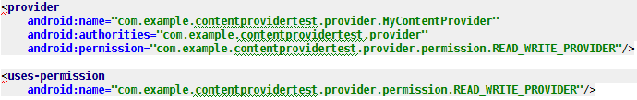

* Permission defined in manifest.xml of the *user*:

